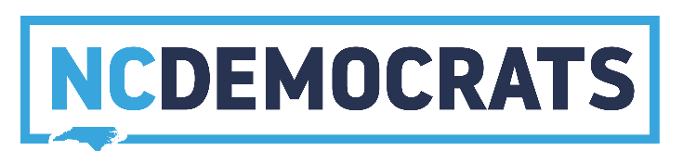
WE BELIEVE IN EQUALITY, OPPORTUNITY, AND PROSPERITY FOR ALL.

220 HILLSBOROUGH STREET RALEIGH, NC 27603 | P.O. BOX 1926 RALEIGH NC 27602 | NCDP.ORG | 919-821-2777
PAID FOR BY THE NORTH CAROLINA DEMOCRATIC PARTY. NOT AUTHORIZED BY ANY CANDIDATE OR CANDIDATE’S COMMITTEE.
Code of Conduct for North Carolina Democratic Party Officers and Leaders at All Levels Our Party’s Plan of Organization states:
“We, the members of the North Carolina Democratic Party, in order to make more effective the principles of our Party, to embrace and serve all peoples of our Party without regard to race, age, gender, color, creed, national origin, religion, ethnic identity, sexual orientation, gender identity, economic status, or physical disability (hereinafter referred to as “status”), to insure the blessings of liberty and equal opportunity, and to work together for the welfare and happiness of all citizens, do hereby adopt and establish this Plan of Organization.”
This applies as much to the internal working of our party as to the type of state and nation we wish to build. Our Party is comprised of paid staff and countless unpaid volunteers from diverse backgrounds, united by our shared values for a better government that works for all Americans. We are further united in our belief that the Democratic Party is a force for positive and progressive change for our state and country in our quest to overcome the gridlock and dysfunction that too often grips our political system.
As Democrats, our united effort is focused on working together toward common goals, treating each other with respect and not allowing our differences to divide us, standing against discrimination against anyone in the party on the basis of status, trusting one another to act in our party’s best interest, being aware of our limitations and collaborating to overcome obstacles, and always seeking feedback to improve our party’s work.
As an officer or leader in our party you have the right to be treated fairly, equally, and within the bounds of party rules. You also have the responsibility to behave in a way that does not negatively impact other members, officers, staff, volunteers, people who interact with the Party in a professional or volunteer capacity, or the party’s reputation.
We encourage robust and passionate debate on policy, strategy, and the way in which our party is governed. We also expect our members to behave lawfully and honestly, to be sensitive to other people’s feelings, and respect their right to have and express views different from their own.
Our responsibilities as party members apply not only to our personal conduct but also to our conduct in communications, including electronic means, and with the media in all its forms. Here is a checklist of questions you should ask yourself as you communicate internally or externally:
● Could what I am intending to do or say or write (in any format) be taken as intimidation, harassment or bullying?
● Is what I say or write the truth?
● Am I acting in the party’s best interests?
● Is what I am doing compliant with electoral law?
● Is what I am doing compliant with data protection standards?
● Is what I am doing in line with our Plan of Organization and the spirit of the Party Platform?
Adopted June 24, 2017 by the NCDP State Executive Council 1
If you are unsure about any of these then take advice before acting. Your precinct, county, congressional district, auxiliary organization, or state party officers are a resource and can act as sounding boards.
Behavior, which is unlawful, dishonest, deceitful, violent, or threatening will be considered to bring the Party into disrepute and can possibly constitute grounds for disciplinary action under the Party’s Plan of Organization vis-a-vis the Council of Review. The party reserves the right to refer any breach of this code of conduct which breaks criminal law to law enforcement as well as dealing with it under this code of conduct.
Though auxiliary organizations are independently governed and chartered by the North Carolina Democratic Party, it is our hope that they will also govern themselves under a similar code of conduct in keeping with their by-laws as approved and sanctioned by the Party’s State Executive Committee.
With your support, we can challenge others who seem to be acting against the spirit of this code and support those who are role models. In this way, we can ensure that we encourage the best in ourselves to thrive and grow.

